TASK 1:
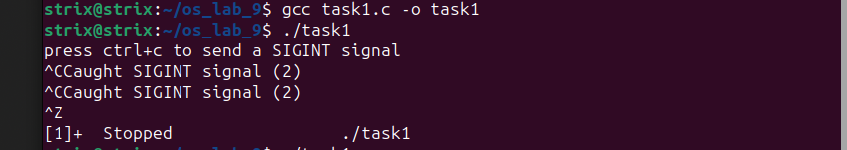
TASK 2:
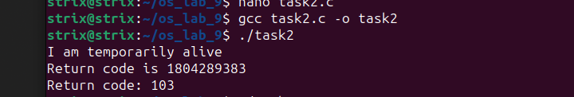
TASK 2 Modified:
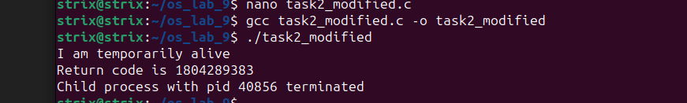
TASK 3:
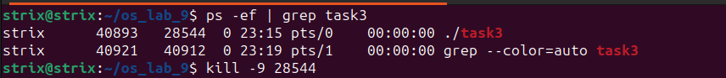
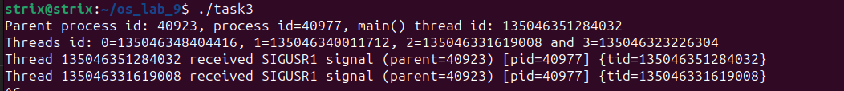
TASK 3 Modified:
